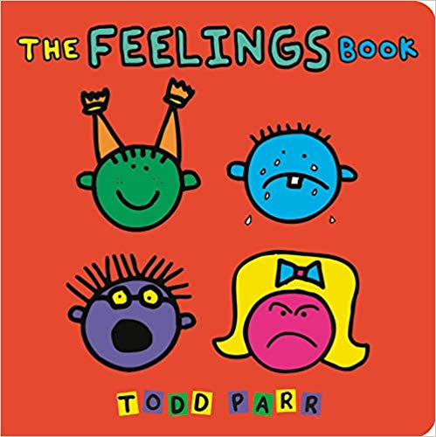

The Feelings Book
Age Range: 2-4 | By Todd Parr
Find it on Amazon.

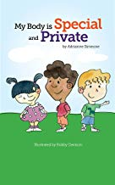

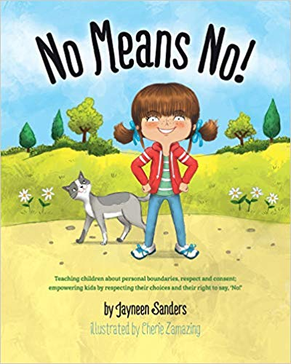
My Body is Special and Private
Age Range: 2-7 | By Adrianne Simeone
Find it on Amazon.

C is for Consent
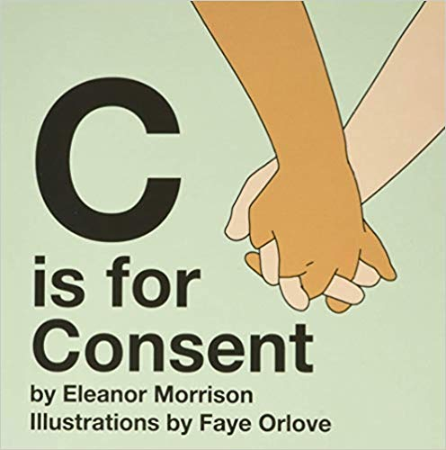
Age Range: 2-5 | By Eleanor Morrison
Find it on Amazon.

No Means No!
Age Range: 2-9 | By Jayneen Sanders
Find it on Amazon.

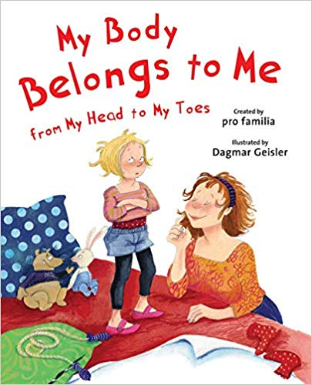
My Body Belongs to Me from My Head to My Toes
Age Range: 3-6 | By Dagmar Geisler
Find it on Amazon.

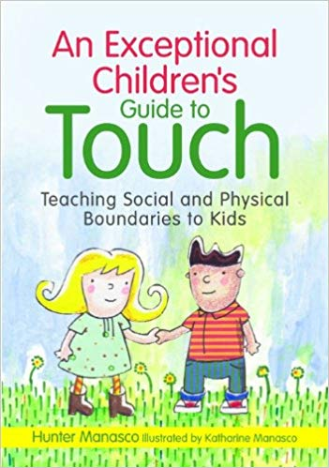
An Exceptional Children’s Guide to Touch
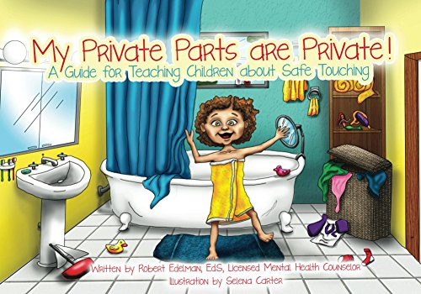
Age Range: 3-11 | By McKinley Hunter Manasco
Find it on Amazon.

My Private Parts are Private! A Guide for Teaching Children about Safe Touching
Age Range: 3-12 | By Robert Edelman
Find it on Amazon.

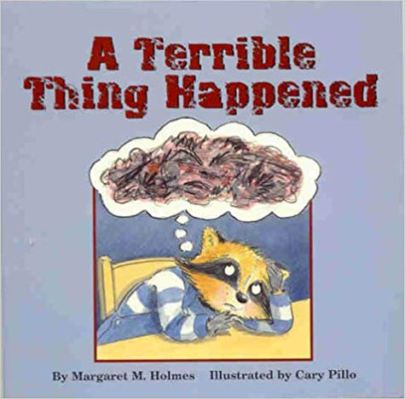
A Terrible Thing Happened
Age Range 4-7 | By Margaret Holmes, Sasha Mudlaff, and Cary Pillo
Find it on Amazon.

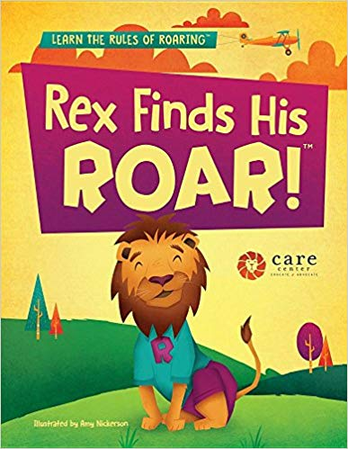
Rex Finds His Roar
Age Range: 4-8 | By The CARE Center
Find it on Amazon.

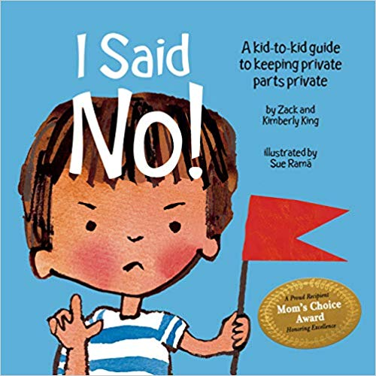
I Said No! A Kid-to-Kid Guide to Keeping Private Parts Private
Age Range: 4-9 | By Zack and Kimberly King
Find it on Amazon.

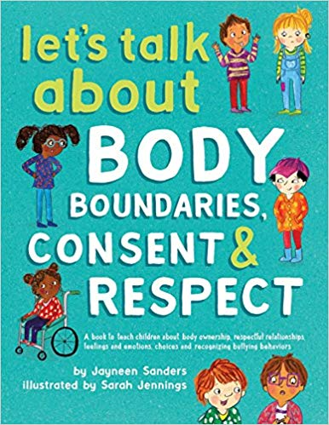
Let’s Talk About Body Boundaries, Consent and Respect
Age Range 4-10 | By Jayneen Sanders
Find it on Amazon.
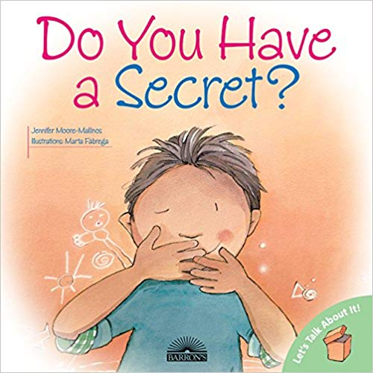

Do You Have a Secret?
Age Range: 6-9 | By Jennifer Moore-Malinos
Find it on Amazon.

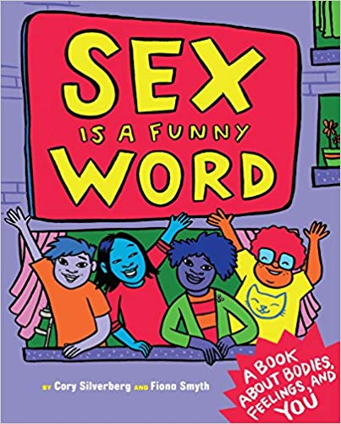

Sex is a Funny Word: A Book about bodies, feelings, and you
Age Range 7-10 | By Cory Silverberg & Fiona Smyth
Find it on Amazon.
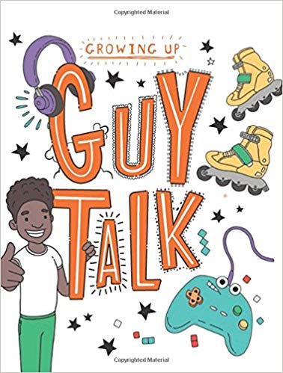

Guy Talk
Age Range: 8-12 | By Lizzie Cox
Find it on Amazon.

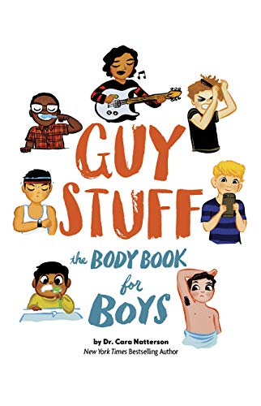

Guy Stuff: The Body Book for Boys
Age Range: 8-12 | By Cara Natterson
Find it on Amazon.

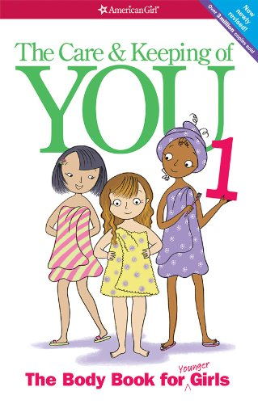
The Care and Keeping of You
Age Range: 8-12 | By Valerie Schaefer
Find it on Amazon.

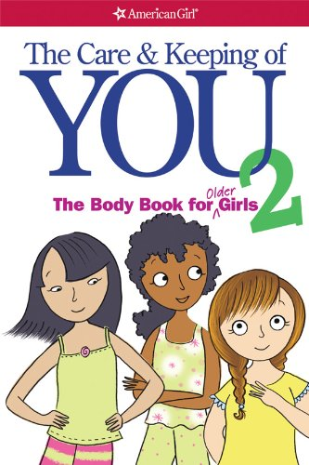

The Care and Keeping of You
Age Range: 8-12 | By Cara Natterson
Find it on Amazon.

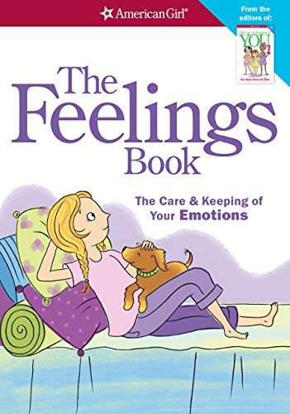
The Feelings Book: The Care and Keeping of Your Emotions
Age Range: 8-12 | By Lynda Madison
Find it on Amazon.

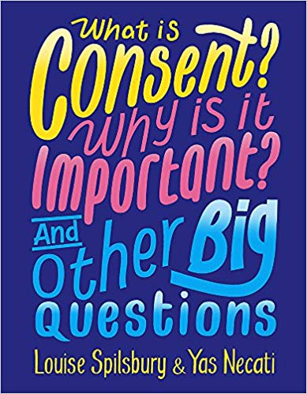

What is Consent? Why is it Important? And Other Big Questions
Age Range: 8-13 | By Yas Necati and Louise Spilsbury
Find it on Amazon.
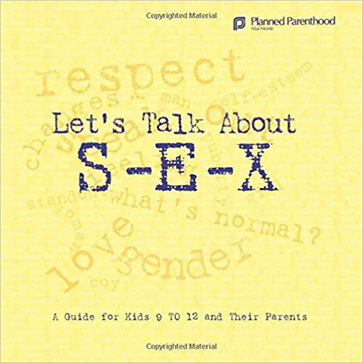
Let’s Talk About S-E-X: A Guide for Kids 9-12 and Their Parents
Age Range: 9-12 | By Sam Gitchel and Lorri Foster
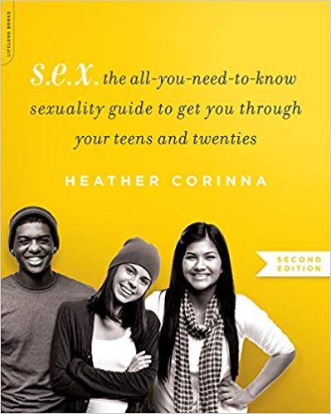
Find it on Amazon.

S.E.X: The All-You-Need-To-Know Sexuality Guide to Get You Through Your Teens and Twenties
Age Range: 12-18 | By Heather Corinna
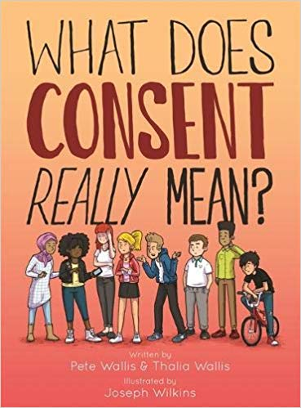
Find it on Amazon.

What Does Consent Really Mean?
Age Range: 13-18 | By Pete Wallis, Joseph Wilkins, and Thalia Wallis
Find it on Amazon.

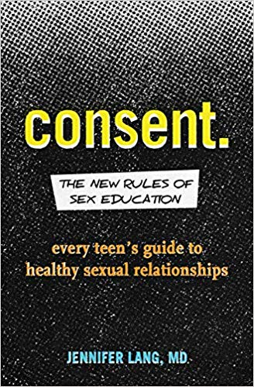

Consent: The New Rules of Sex Education — Every Teen’s Guide to Healthy Sexual Relationships
Age Range: 13-18 | By Jennifer Lang, MD
Find it on Amazon.

Girl Made of Stars
Age Range: 14-17 | By Ashley Herring Blake
Find it on Amazon.
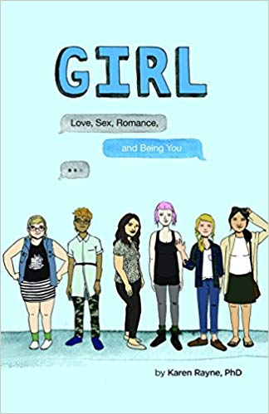
GIRL: Love, Sex, Romance, and Being You
Age Range: 15-19 | By Karen Rayne, PhD
Find it on Amazon.

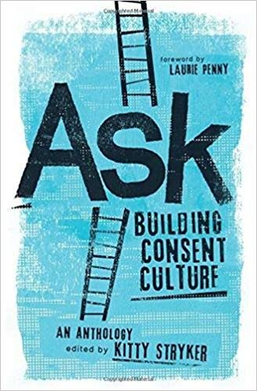

Ask: Building Consent Culture
Age Range: 15 and up (a good read for parents too) | By Kitty Stryker
Find it on Amazon.

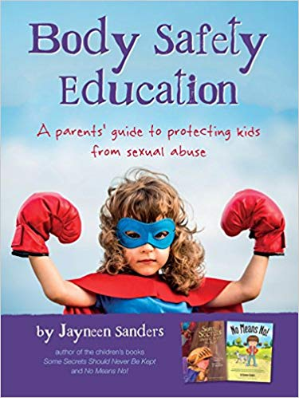

Body Safety Education: A Parents’ Guide to Protecting Kids from Sexual Abuse
Age Range: Parents/Caregivers | By Jayneen Sanders
Find it on Amazon.

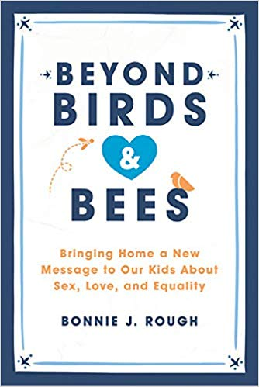
Beyond Birds and Bees: Bringing Home a New Message to Our Kids About Sex, Love, and Equality
Age Range: Parents/Caregivers | By Bonnie Rough
Find it on Amazon.
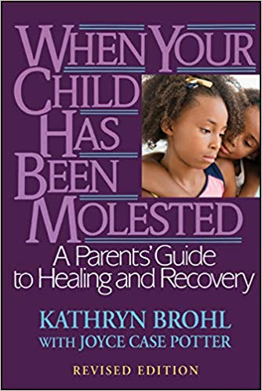
When Your Child has been Molested: A Parent’s Guide to Healing and Recovery
Age Range: Parents/Caregivers | By Kathryn Brohl
Find it on Amazon.
Note: If you have a history of traumatic exposure, please discuss these books with an Advocate, as some options may not be appropriate for you.
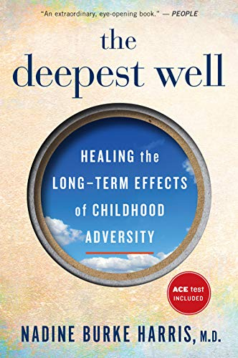
The Deepest Well: Healing the Long-Term Effects of Childhood Adversity
Age Range: Parents/Caregivers | By Nadine Burke Harris, M.D.
Find it on Amazon.
Note: If you have a history of traumatic exposure, please discuss these books with an Advocate, as some options may not be appropriate for you.
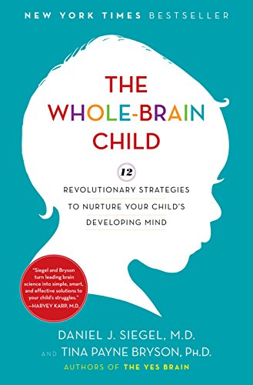
The Whole-Brain Child: 12 Revolutionary Strategies to Nurture Your Child's Developing Mind
Age Range: Parents/Caregivers | By Daniel Siegel & Tina Payne Bryson
Find it on Amazon.
Note: If you have a history of traumatic exposure, please discuss these books with an Advocate, as some options may not be appropriate for you.

The Body Keeps the Score: Brain, Mind, and Body is the Healing of Trauma
Age Range: Parents/Caregivers | By Bessel Van Der Kolk, M.D.
Find it on Amazon.
Note: If you have a history of traumatic exposure, please discuss these books with an Advocate, as some options may not be appropriate for you.
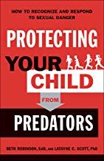
Protecting your Child from Predators
Age Range: Parents/Caregivers | By Beth Robinson, Latayne C. Scott
Find it on Amazon.

